Physics Unit 3 NAME: SOLUTIONS\_\_\_\_\_\_\_\_\_\_\_\_\_\_\_



**ELECTRICITY and MAGNETISM TOPIC TEST 2019**

*(50 Marks, 50 Minutes + 5 Min reading)*

**QUESTION 1 (4 Marks)**

a) Draw a diagram of the **resultant** magnetic field between the two magnets when a wire carrying a current into the page is placed between the two magnets. Show at least five lines.

(2 marks)

ex64_Pic6

*At least 5 lines in right direction ✓*

*Bigger spacing on top ✓*

b) The situation depicted in part (a) results in a force acting on the current carrying wire. If the magnetic field strength in the vicinity of the wire is 2.50 T, the length of wire in the field is 30.0 mm and a current of 6.00 A is carried by the wire, calculate the **magnitude and direction** of the force on the wire.

(2 marks)

*✓✓*

**QUESTION 2 (4 Marks)**

**ex19E_Pic2**Electromagnetic induction can be used to heat food in modern kitchens. When an electric current is used in the coil, the food can be cooked due to the heat generated by this arrangement.

Using the principles of electromagnetic induction, describe how this arrangement produces enough heat to cook food.

(4 marks)

AC current in coil *✓*

Induces eddy currents in base of pot *✓* via Faradays’s Law *✓*

Eddy currents generate heat *✓*

**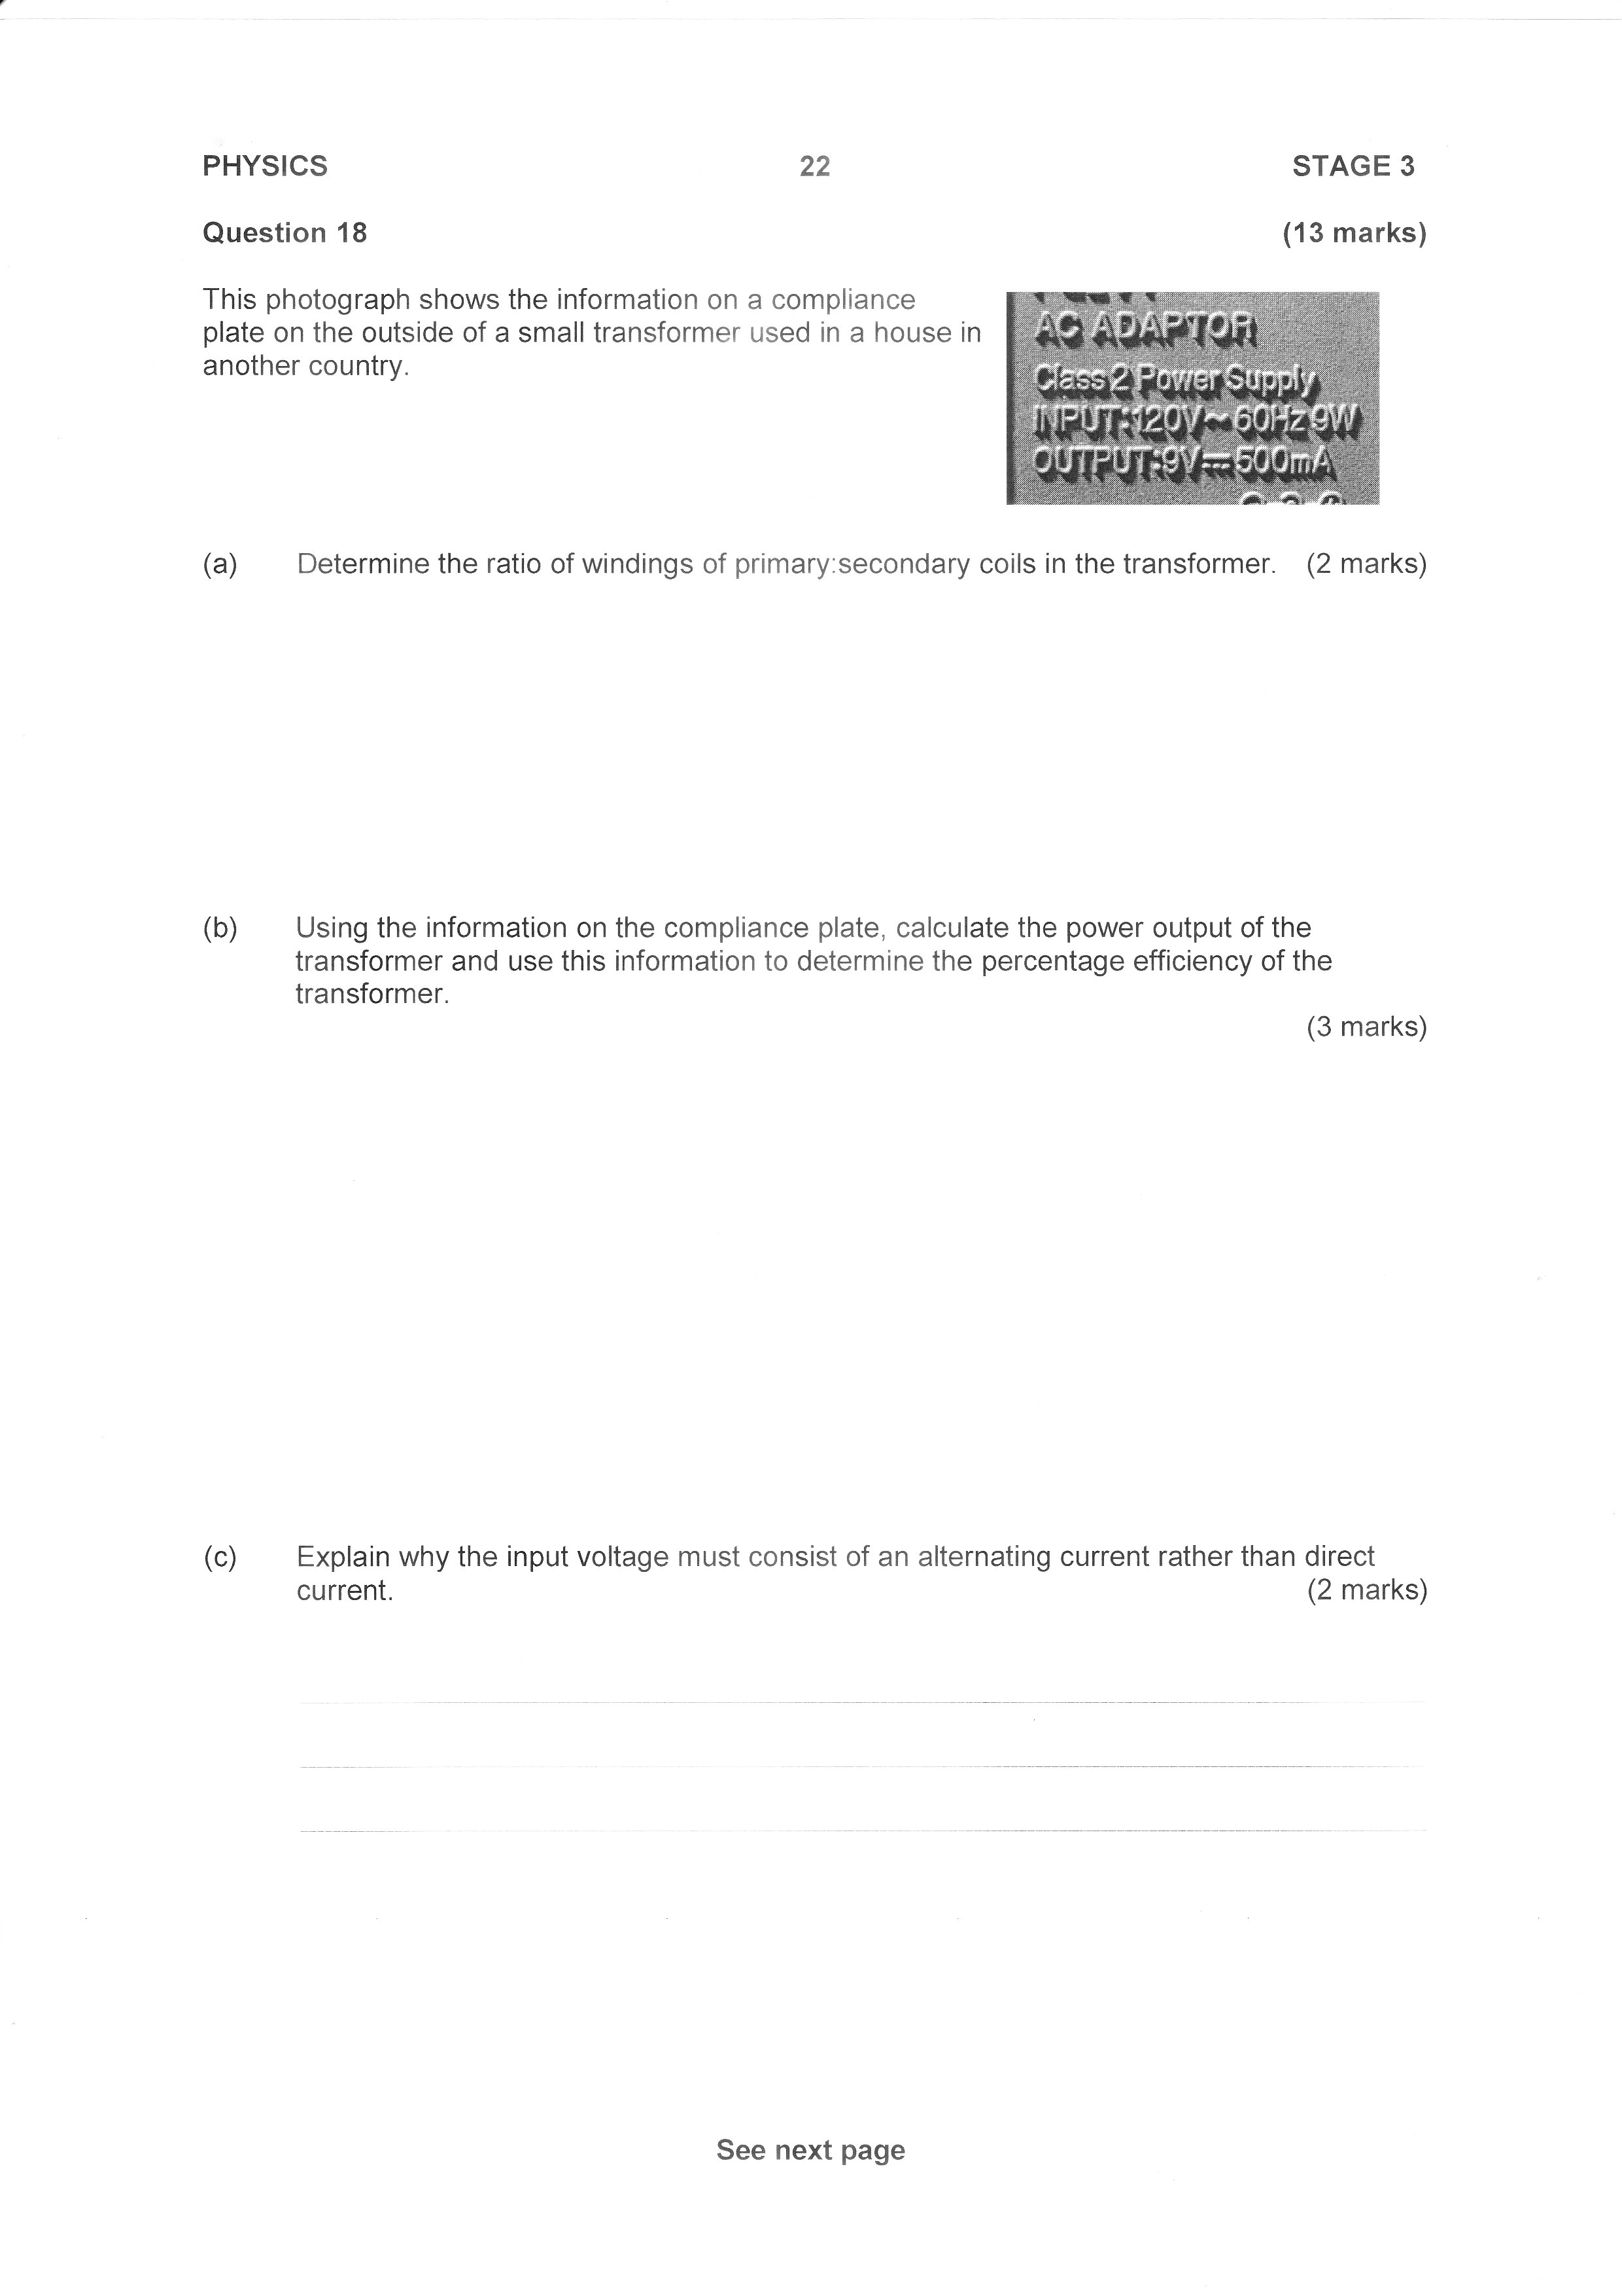QUESTION 3 (5 Marks)**

This photograph shows the information on a compliance plate on the outside of a small transformer used in a house in another country.

1. If there are 45 windings (loops) on the secondary coil, how many windings on the primary coil?

(2 Marks)

*✓*

*600 windings on the primary coil. ✓*

b) Using the information on the compliance plate, calculate the power output of the transformer and use this information to determine the percentage efficiency of the transformer.

(3 Marks)

Power input = 9 Watts *✓*

Power output =

*✓*

Efficiency = 50% *✓*

**QUESTION 4 (6 Marks)**

Top Plate = +9350 V

Bottom Plate

Charged Particle

21 mm

A positively charged particle enters a region between two parallel plates set at different voltages. The distance between the plates is 21.0 mm. The electric field strength in the region between the plates is 3.50 × 105 V m-1.

1. Calculate the voltage of the bottom plate.

(3 Marks)

*✓*

*✓*

*✓*

1. The charged particle experiences a force of magnitude 1.40 ×10-11 N that causes it to deflect towards the bottom plate. Determine the magnitude of charge of the particle.

(2 Marks)

*✓*

*✓*

1. Use five lines with arrowheads to indicate the uniform electric field in the region between the plates.

(1 Mark)

*5 evenly spaced lines pointing down ✓*

**QUESTION 5 (4 Marks)**

An electron and a proton both enter a uniform magnetic field as shown in the diagram below.

The speed of both isand the field strength is .

The field is directed into the paper.



A

(a) On the diagram draw the path of an electron in the magnetic field. Label it A. *✓*

(1 Mark)

(b) Calculate the radius of A.

(2 Marks)

*✓*

*✓*

(c) Draw the approximate path of a proton and label it B. No calculation is required.

(1 Mark)

*Bigger radius in opposite direction* *✓*

**QUESTION 6 (4 Marks)**

1. The centres of two electrons in a vacuum are separated by distance $d$ m and experience force $F$ as a result of electromagnetic repulsion. In terms of $F$, what force will they experience if the distance between them is halved?

*4F* *✓* (1 Mark)

1. Two electrons in a vacuum experience a repulsive force of $7.19×10^{-23}N$. How far are the electrons apart?

(3 Marks)

*✓*

*✓*

*✓*

**TAE 87_Pic3QUESTION 7 (8 Marks)**

a i) A bar magnet passed through a coil as shown induces an emf in the coil. List 3 ways by which such an emf could be increased.

*\_\_\_\_Increase speed of motion\_\_\_\_\_\_\_\_\_\_\_\_\_✓*

**+**

*\_\_\_\_Increase strength of magnet\_\_\_\_\_\_\_\_\_\_\_✓*

*\_\_\_\_Increase number of windings in coil*\_\_\_\_*✓*

(3 marks)

ii) Mark on one end of the coil the direction of the induced current. *✓*

(1 Mark)

iii) Mark the end of the coil that will become positive with a “+” sign. *✓*

(1 Mark)

b If magnet A below is set oscillating vertically so that it moves in and out of the solenoid, explain in detail what effect if any, will this have on the identical magnet B and why.

Elec E_Pic1

(3 marks)

*Magnet A induces emf in coil A and hence coil B (Faraday’s Law) ✓*

*Current induced in coil B will create field causing force on Magnet B ✓*

*Force causes B to oscillate ✓*

**QUESTION 8 (6 Marks)**

a A high-speed electric train picks up power from the overhead line through a pantograph arm; the other connection is made to earth through the rails. The height of the overhead line above the rails is 5.0 m.

TEE93L2_Pic4

The train is travelling from east to west at 80.0 ms-1 and the horizontal component of the Earth's magnetic field is

20.0 T. What would be the voltage induced between the overhead line and the rails?

(2 marks)

*✓*

V *✓*

b) A coil of 5.00 x l02 turns and area 1.00 x 10-4 m2 is situated in a controlled variable magnetic field. At t = 0 sec, the field is increased at a uniform rate from its initial value of 0.300 Wb m-2 to 0.800 Wb m-2 during a period of 5.00 seconds, and it is held at that value thereafter.

On the axes provided, plot a graph to show how the emf induced in the coil varies with time **before, during and after** the field is increased. Place a suitable label and scale on the vertical axis of your graph, and show your working in the space provided below. (4 marks)

Emf (mV)

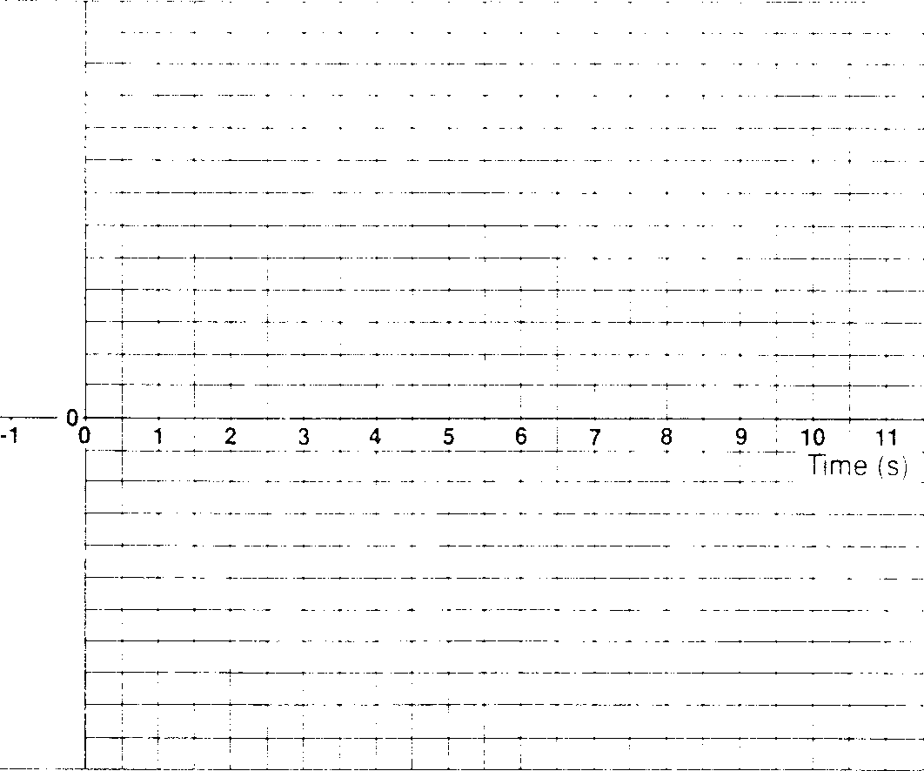

5

$$emf=\frac{-n∆∅}{∆t}$$

$=\frac{-500(0.5)(1×10^{-4})}{5}$

$=5 ×10^{-3}$ V *✓✓*

*Two flat lines**✓✓*

**QUESTION 9 (9 Marks)**

Analogue meters, like the one shown in the diagram below, have many applications: for example, in pool chlorination systems. The interaction of the electric current in the coil and the permanent magnet creates a torque. A fine spring (hair spring) provides a restoring torque.

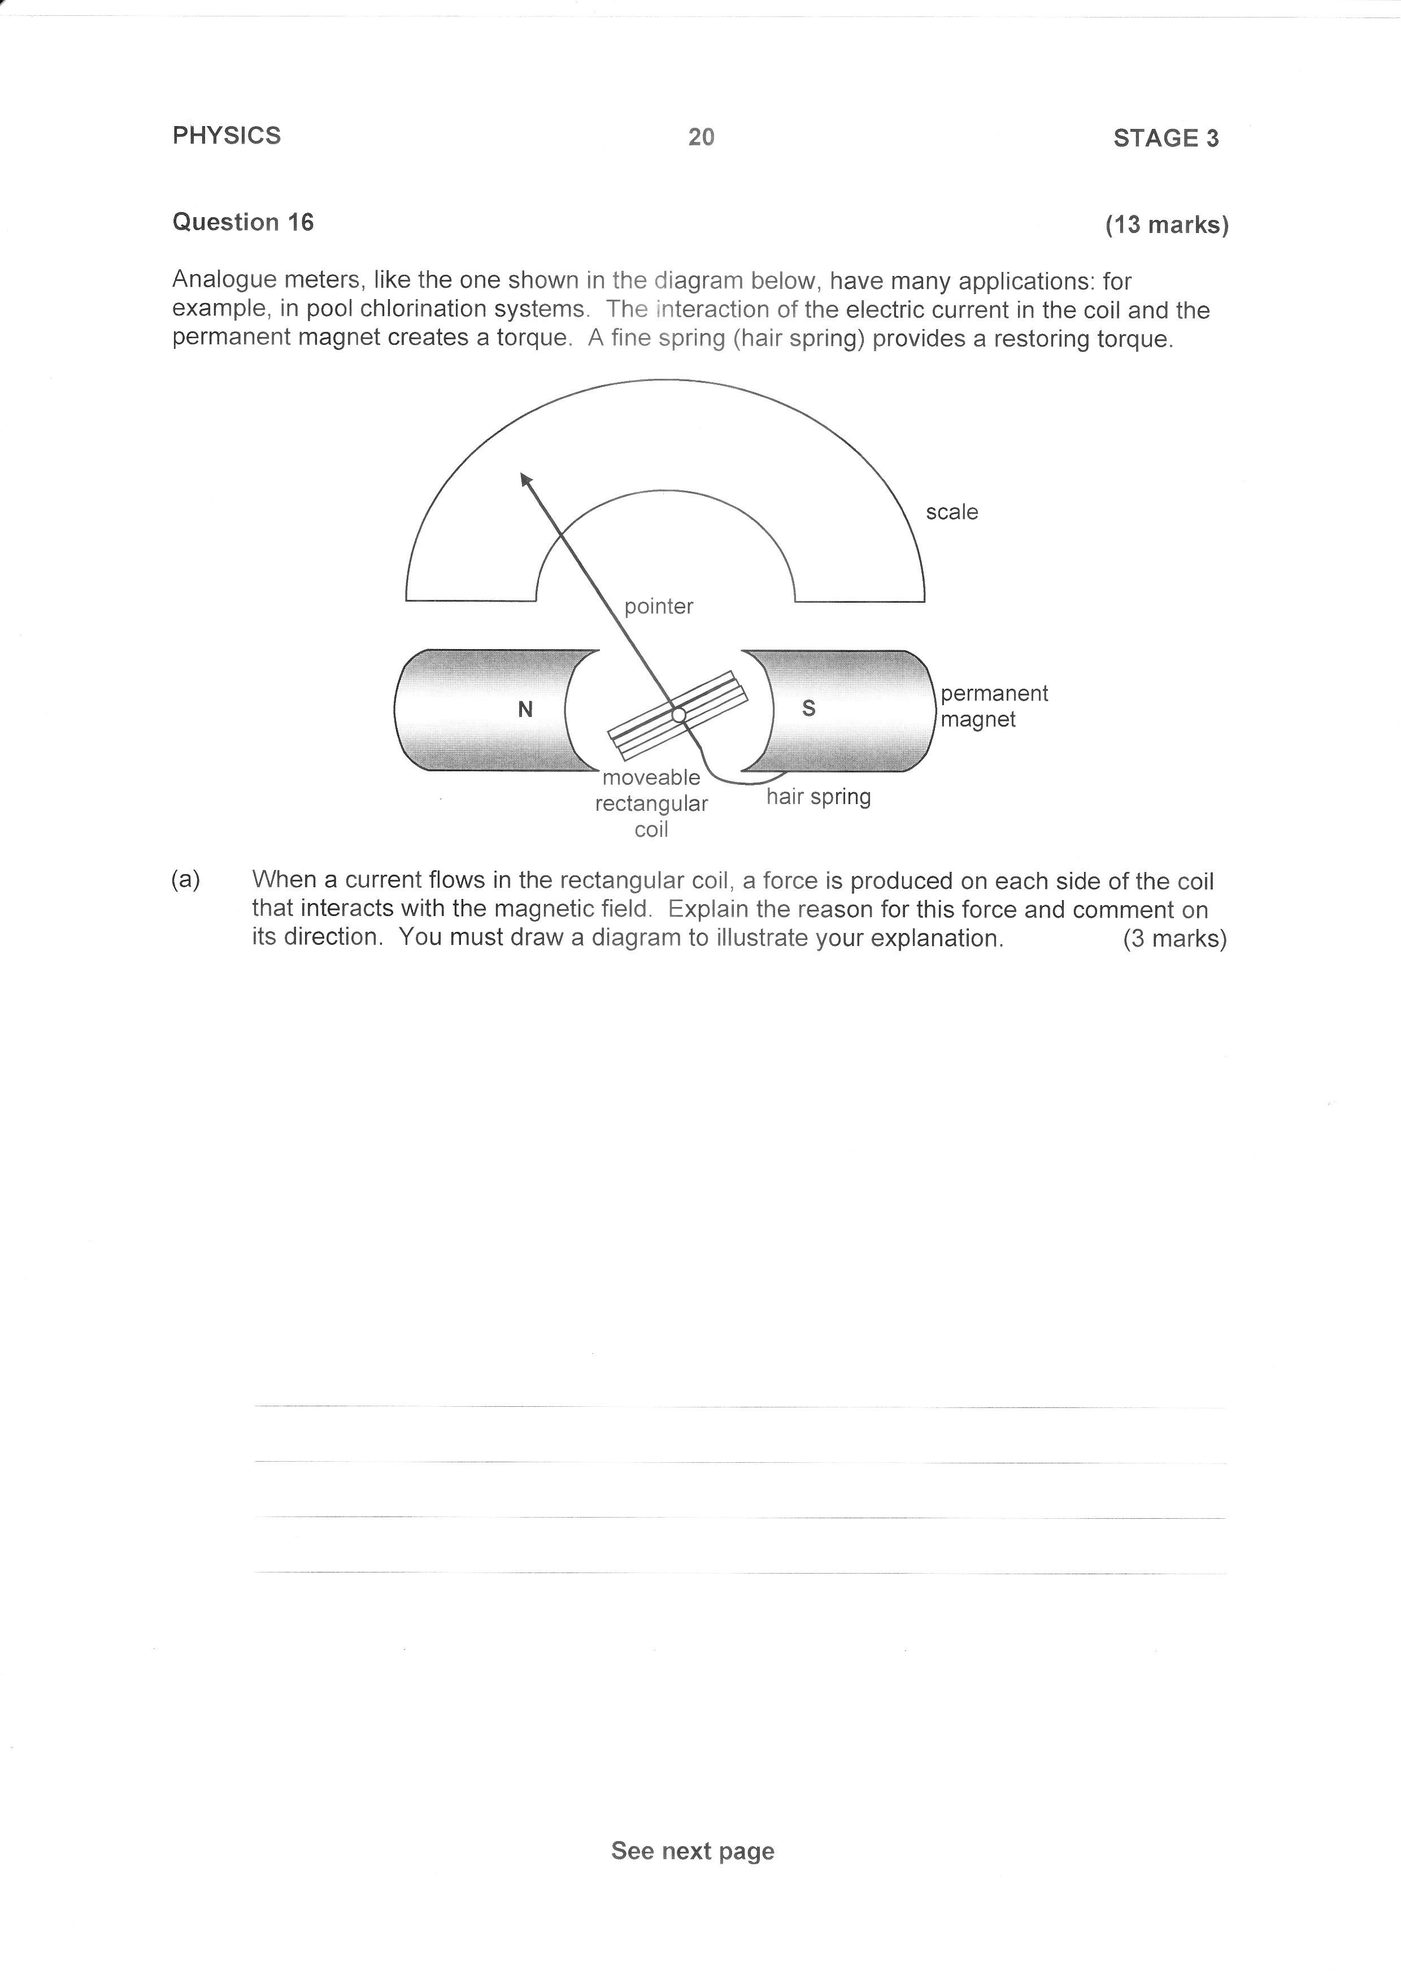

0 V

a) When a current flows in the rectangular coil, a force is produced on each side of the coil that interacts with the magnetic field. Explain the reason for this force and comment on its direction. You must draw a diagram to illustrate the direction that current is flowing.

(3 Marks)

*Current in coil generates field* *✓ which interacts with field of permanent magnets creating force ✓*

S

N

*✓*

b) The coil has a length of 0.100 m and a width of 0.0800 m and has 50.0 turns. There is a current of 4.00 A in the coil and it is a uniform magnetic field of 0.0100 T.

i) Calculate the force on one strand of one of the long sides of the coil

(2 Marks)

*✓*

*✓*

ii) Hence determine the electromagnetic torque acting on the coil.

(3 Marks)

*✓*

*✓*

*✓*

d) The loosely-coiled spring provides a torque that opposes the coil’s rotation. When the coil is stationary, with a current flowing in it, state the relationship between the torque acting on the coil because of the magnetic field, and the torque provided by the spring.

(1 Mark)

*The two torques are of equal magnitude but in opposite directions. ✓*

**END OF TEST**

Magnet moving away from coil